Interjection

🟣 What is an Interjection?
# Source: AI Source: Provided by: [Data Path: Persons Table -> ID Column: 1, Name_En Column: Motasem Essam] -> From: [Chatgpt (GPT-4-turbo)] on [7/24/2025]
An interjection is a word or short phrase used to express strong emotion or reaction.
It’s often used on its own, and it’s not grammatically connected to the rest of the sentence.

📘 Definition:
# Source: AI Source: Provided by: [Data Path: Persons Table -> ID Column: 1, Name_En Column: Motasem Essam] -> From: [Chatgpt (GPT-4-turbo)] on [7/24/2025]
An interjection is a word or expression that shows emotion, such as surprise, joy, anger, or pain. It usually stands alone or comes at the beginning of a sentence.

🧠 Examples of Interjections:
# Source: AI Source: Provided by: [Data Path: Persons Table -> ID Column: 1, Name_En Column: Motasem Essam] -> From: [Chatgpt (GPT-4-turbo)] on [7/24/2025]
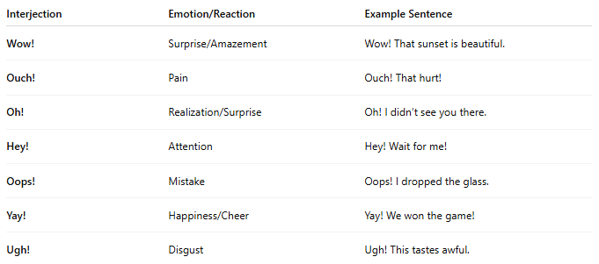
Interjection | Emotion/Reaction | Example Sentence
Wow! | Surprise/Amazement | Wow! That sunset is beautiful.
Ouch! | Pain | Ouch! That hurt!
Oh! | Realization/Surprise | Oh! I didn’t see you there.
Hey! | Attention | Hey! Wait for me!
Oops! | Mistake | Oops! I dropped the glass.
Yay! | Happiness/Cheer | Yay! We won the game!
Ugh! | Disgust | Ugh! This tastes awful.

🔤 Punctuation with Interjections:
# Source: AI Source: Provided by: [Data Path: Persons Table -> ID Column: 1, Name_En Column: Motasem Essam] -> From: [Chatgpt (GPT-4-turbo)] on [7/24/2025]
- Use an exclamation mark (!)
  - Wow! That’s amazing!
- Use a comma (,) for softer emotions or when part of a sentence
  - Well, I guess that’s true.

✅ Summary:
# Source: AI Source: Provided by: [Data Path: Persons Table -> ID Column: 1, Name_En Column: Motasem Essam] -> From: [Chatgpt (GPT-4-turbo)] on [7/24/2025]
An interjection is a short word or phrase that expresses emotion.
It’s often followed by an exclamation mark and can stand alone.

